Task 01
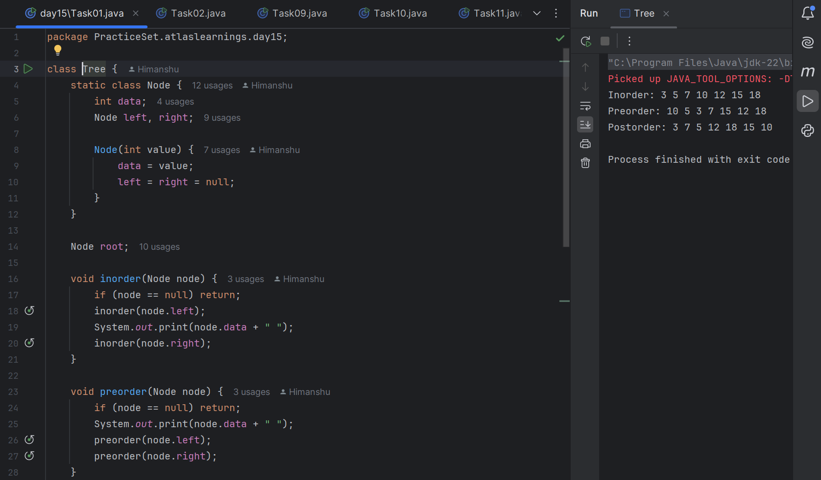
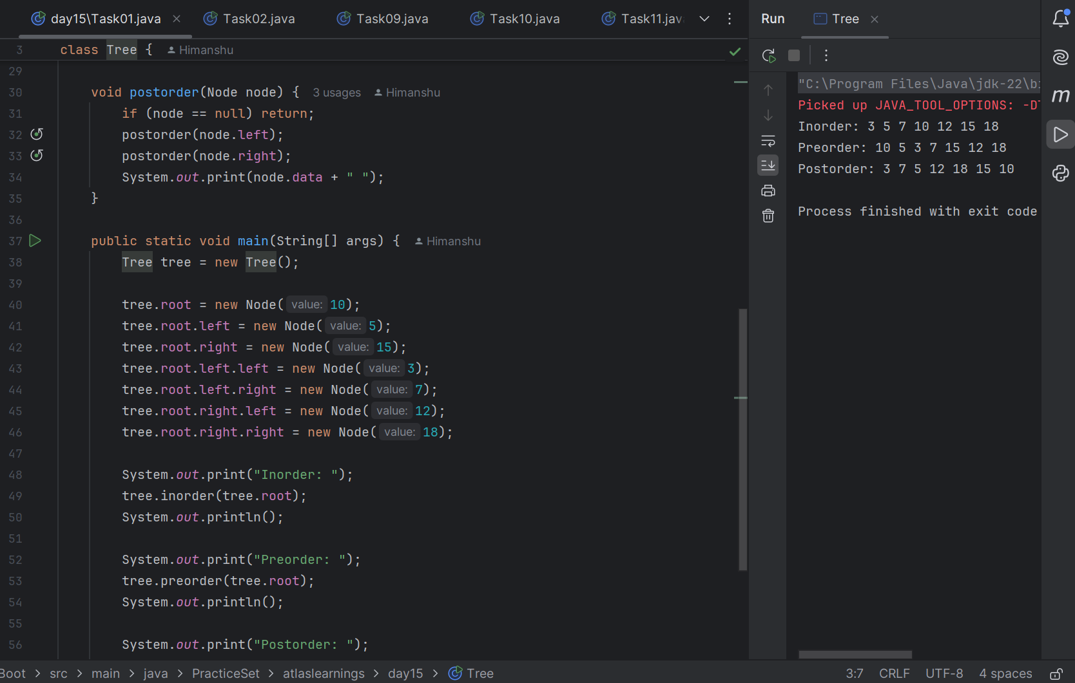
Task 02 - Task 04
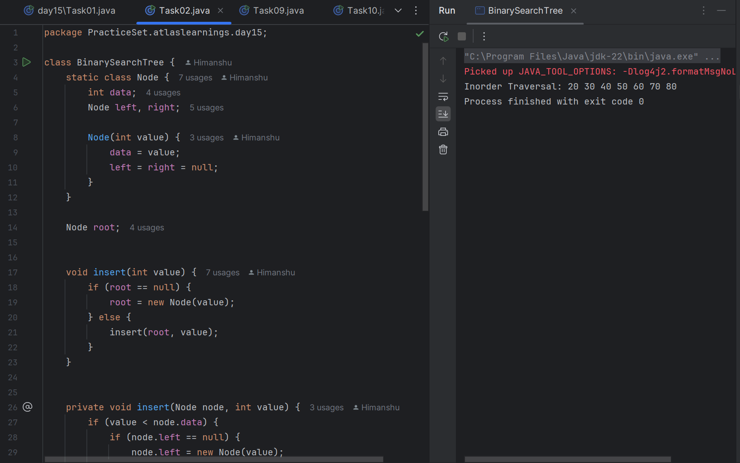
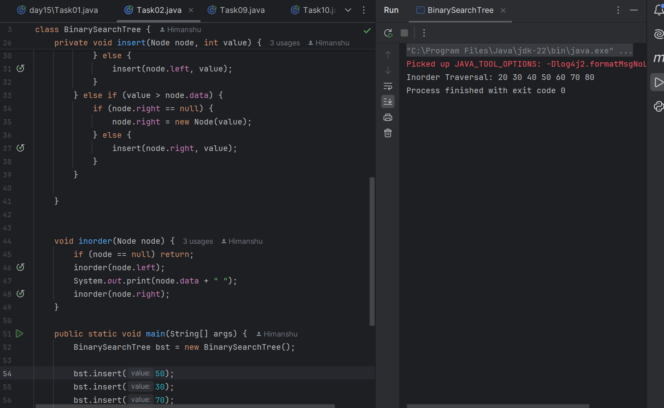
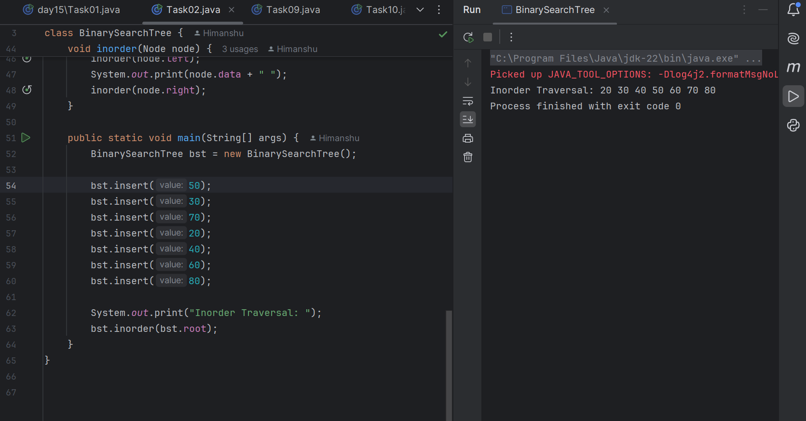

Task 05

Application of Trees

Hierarchical Data Representation
Binary Search Tree
Heaps
Tries
Segment Trees
B-Trees / B+ Trees
Decision Trees
Syntax Trees
Routing and Network Trees

Task 06
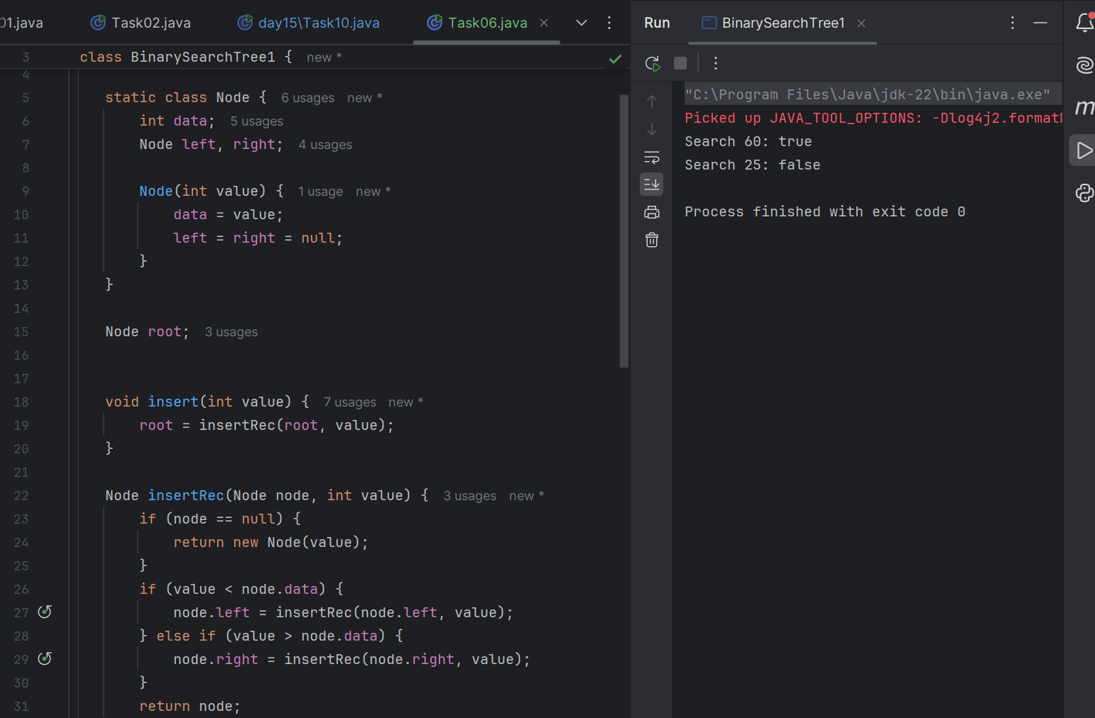
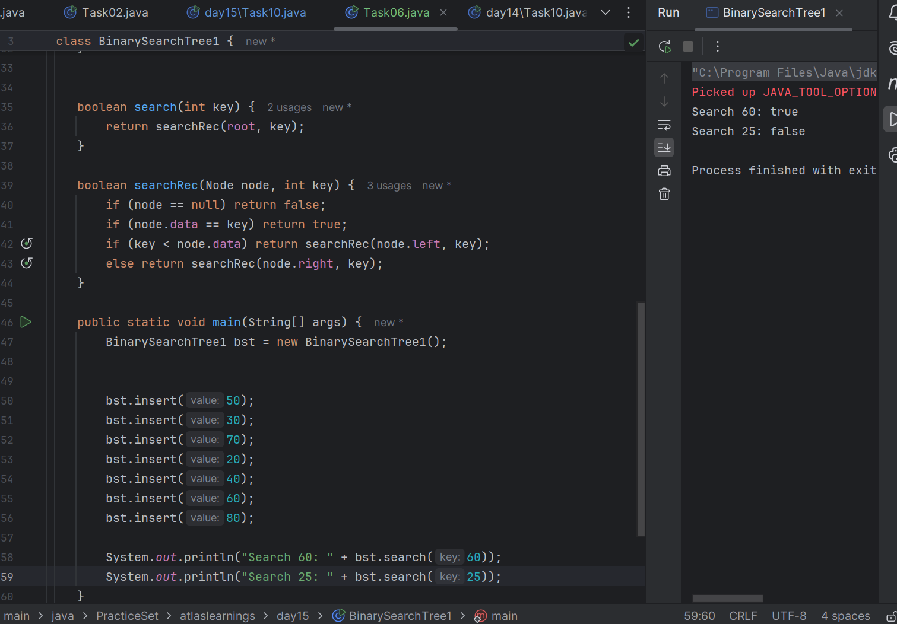

Task 07
Types of Binary Trees
- Full Binary Tree
- Perfect Binary Tree
- Complete Binary Tree
- Balanced Binary Tree
- Binary Search Tree
- Skewed Binary Tree

Task 08
Application of Graph Data Structure
Social Networks
Google Maps and Navigation
Web Crawling
Recommendation System
Computer Networks
Dependency Resolution
AI/ML learning
Circuits and Electric Networks

Task 09

Types of Graphs

Directed Graph
Undirected Graph
Weighted Graph
Unweighted Graph
Cyclic Graph
Connected Graph
Disconnected Graph
Sparse Graph
Complete Graph

Task 10
